Challenge Task 1:
- Launch one instance ec2 and install
Jenkins.
# Ec2 instance with the name Jenkins of amazon linux machine has been
launched and is running with downloaded pem file on my machine
- Accessed the instance on moboxterm using the command ssh -i "jenkins.pem" ec2-user@ec2-54-235-39-23.compute-1.amazonaws.com from the pem file location
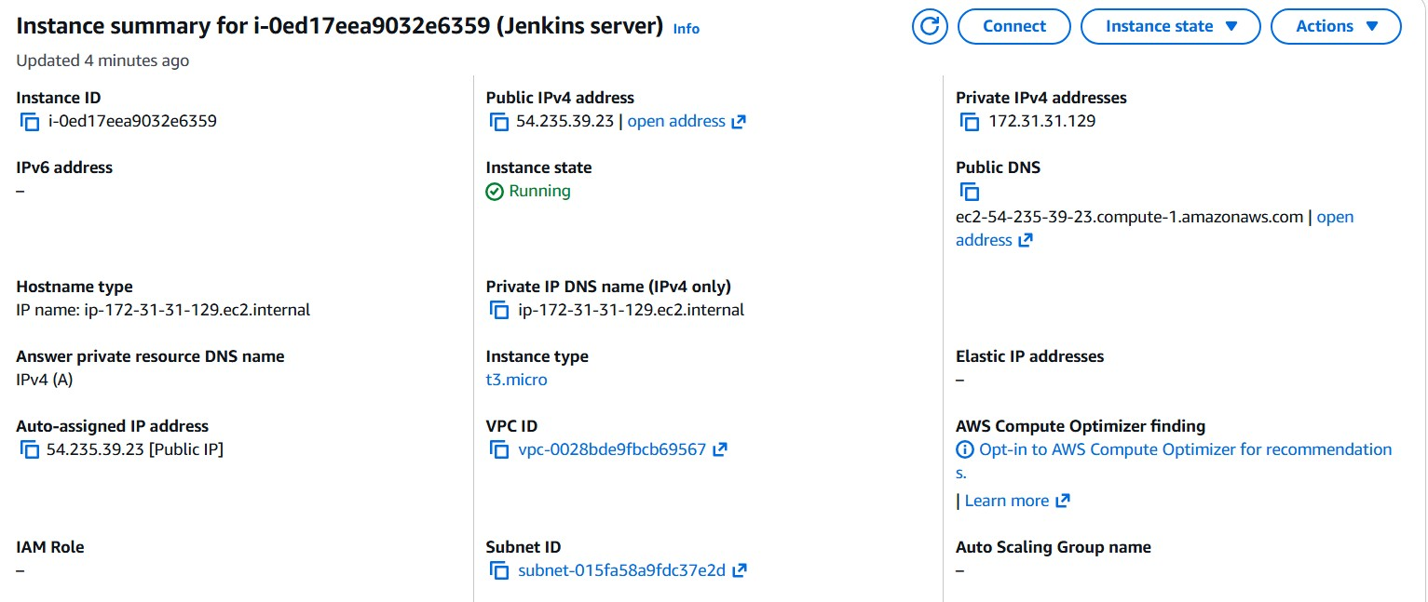
- Install java using command sudo yum install java -y
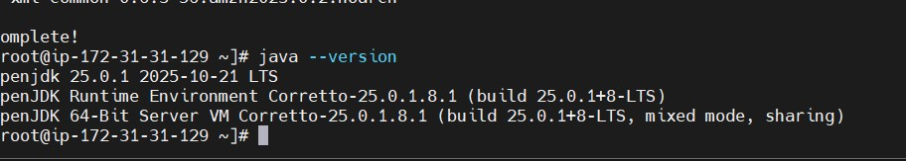
- sudo wget -O /etc/yum.repos.d/jenkins.repo https://pkg.jenkins.io/redhat/jenkins.repo
sudo rpm --import https://pkg.jenkins.io/redhat/jenkins.io.key
sudo yum install jenkins -y
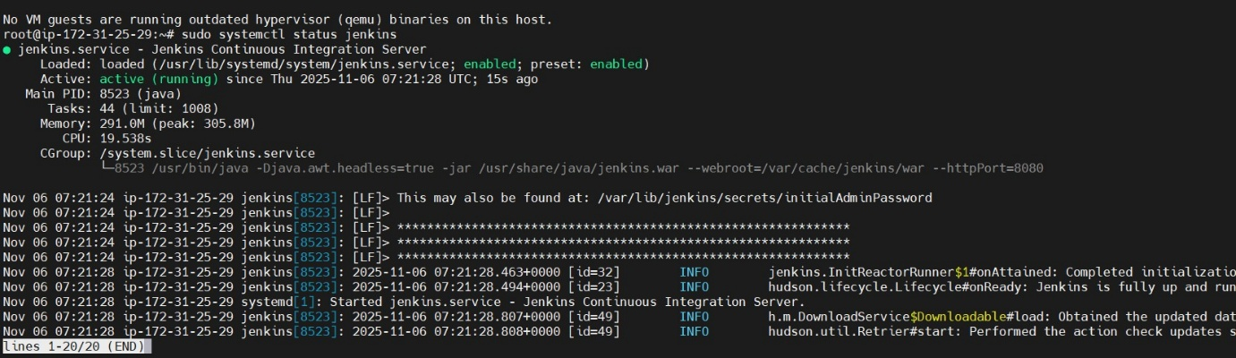

2. 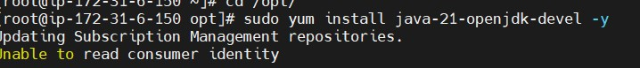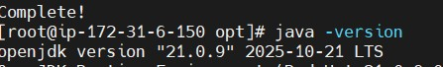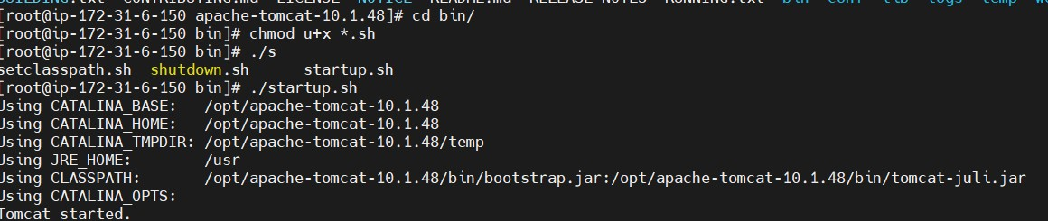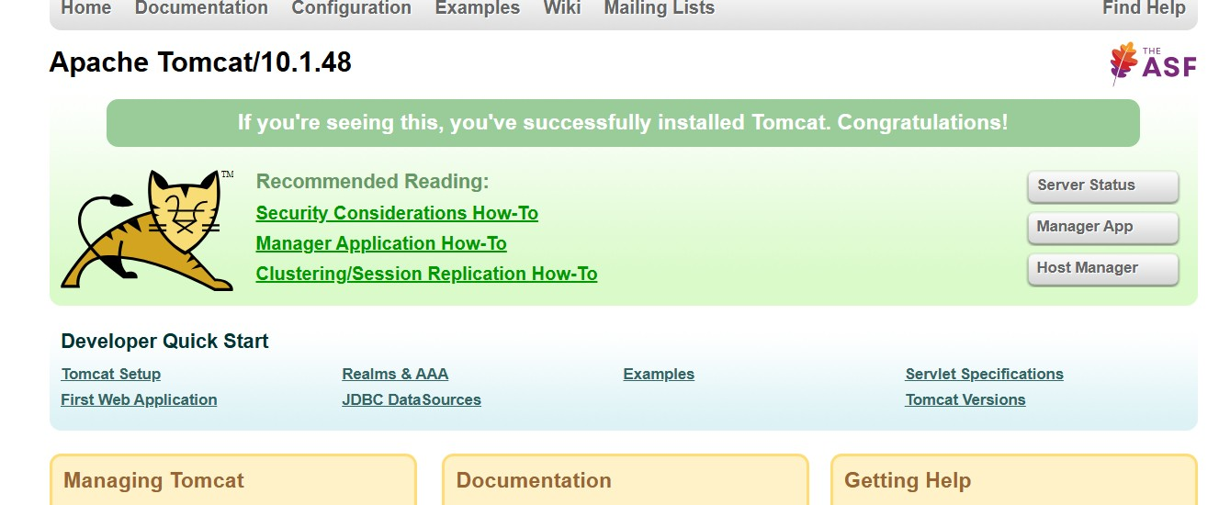
3. Setup Docker Desktop on your local windows.
